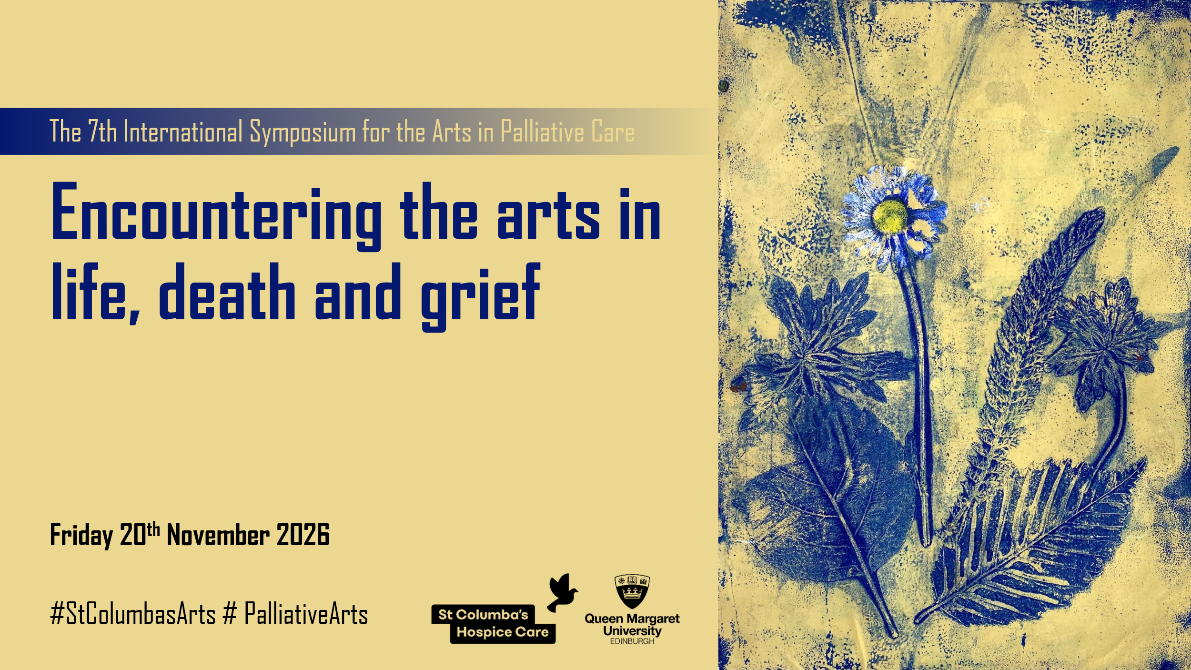
POSTER PROPOSAL SUBMISSION FORM

Please email your completed form to arts@stcolumbashospice.org.uk by 30th August 2026.
All proposals will be reviewed by the organising team, and review outcomes will be communicated by the end of August. For each accepted poster proposal, at least one presenter will need to register to the Symposium by the end of September.

Presenter names and affiliations (e.g. Joe Bloggs, University of X, UK)
Click or tap here to enter text.

Name and email address of contact presenter
Name: Click or tap here to enter text.
Email address: Click or tap here to enter text.

Poster title
Click or tap here to enter text.

Abstract (max 200 words)
Click or tap here to enter text.

Keywords (max 5 words)
Click or tap here to enter text.

References (max 5 references) (optional)
Click or tap here to enter text.

As a hybrid event, the symposium welcomes both in-person and online poster presentations. How do you wish to present your poster? (please tick one)
☐ In-person poster (A1 portrait) and online (PDF copy) for online delegates
☐ Online poster (PDF copy) only

